CCS English: GRADE 7/8
Overview*:
This year we will continue to practice reading, writing, speaking and listening skills through various activities that align with the CT Common Core Standards for grade 7/8. You will be challenged even more to take ownership over your learning experiences. You will have many opportunities to be the leaders of your own discussions and activities. There will still be whole class novels, literature circles, and IR books. We will also read short stories, non-fiction articles, and poetry. You will write about what you read in many different ways, including the 3 main types of writing outlined in the CT Common Core: Argumentative, Narrative, and Informative. You will continue to work on story elements, figurative language, vocabulary development, and presentation skills. You will become more familiar with literary analysis and in-text citations. You will work independently, in pairs, in small groups, and as a whole class. You will be asked to utilize the Chrome books and Google Classroom regularly. We will incorporate other technologies (Glogster, Animoto, Blogger, Quizlit, etc.) whenever possible.

Adolescent Identity: Who am I? What are the various factors that shape one’s identity? How does society influence our identity and the choices we make?
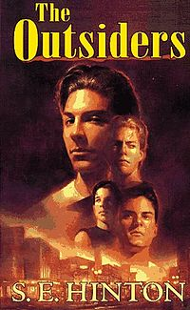
“No one ever said life was easy. But Ponyboy is pretty sure that he's got things figured out. He knows that he can count on his brother... And he knows that he can count on his friends—true friends who would do anything for him, And when it comes to the Socs—a vicious gang of rich kids who enjoy beating up on "greasers" like him—he knows that he can count on them for trouble. But one night someone takes things too far, and Ponyboy's world is turned upside down...”
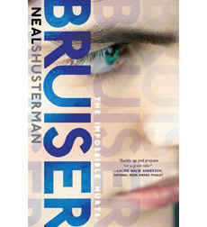
“When Brontë starts dating Brewster “Bruiser” Rawlins – the guy voted “Most Likely to Get the Death Penalty” her twin brother, Tennyson, isn’t surprised. But then strange things begin to occur…What at first seems like their good fortune turns out to be more than they bargained for…much more.” Told through Tennyson, Brontë, and Bruiser's points of view, this dark, twisting novel explores friendship, family, and the sacrifices we make for the people we love.”
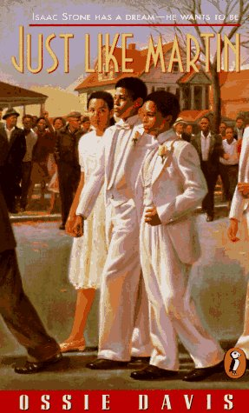
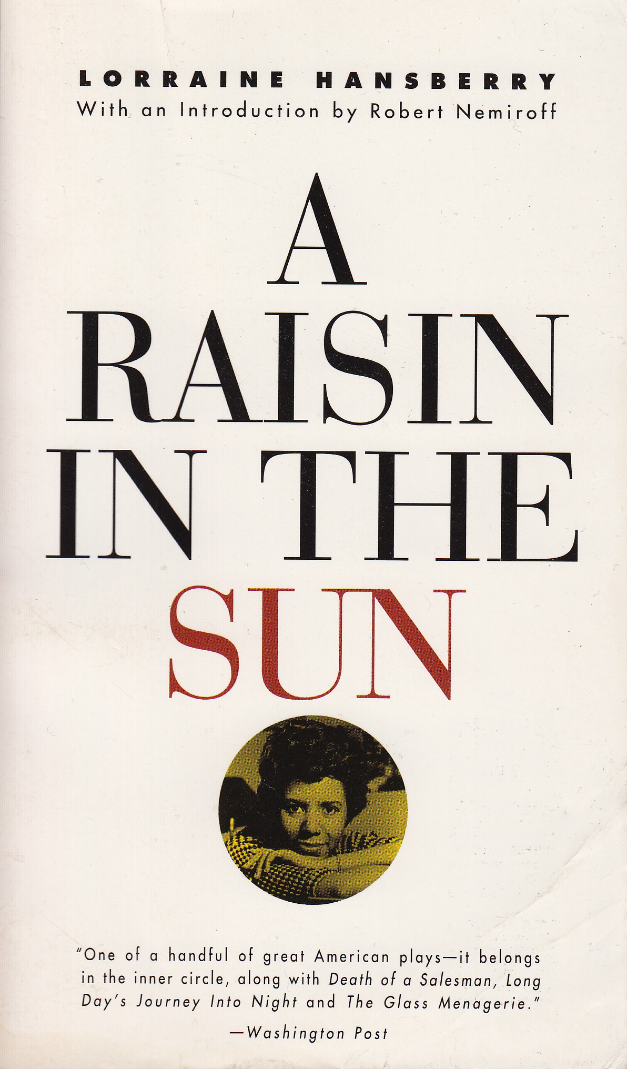
Both of these novels provide a great springboard for discussion and writing assignments related to powerful themes such as unconditional love, empathy, bullying, addiction, heroism, and the meaning of friendship and family. You will take turns leading the class discussion on the nightly reading. The reading will spark research and informative writing about many real-world topics related to the setting and events in the novels.

The African- American Experience and Civil Rights:
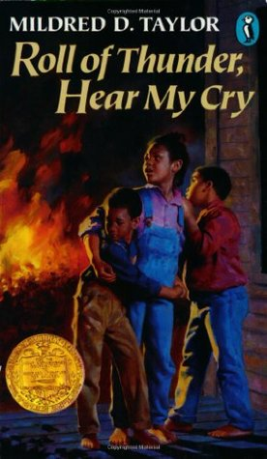
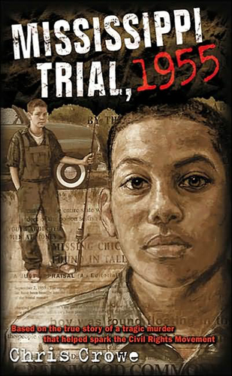
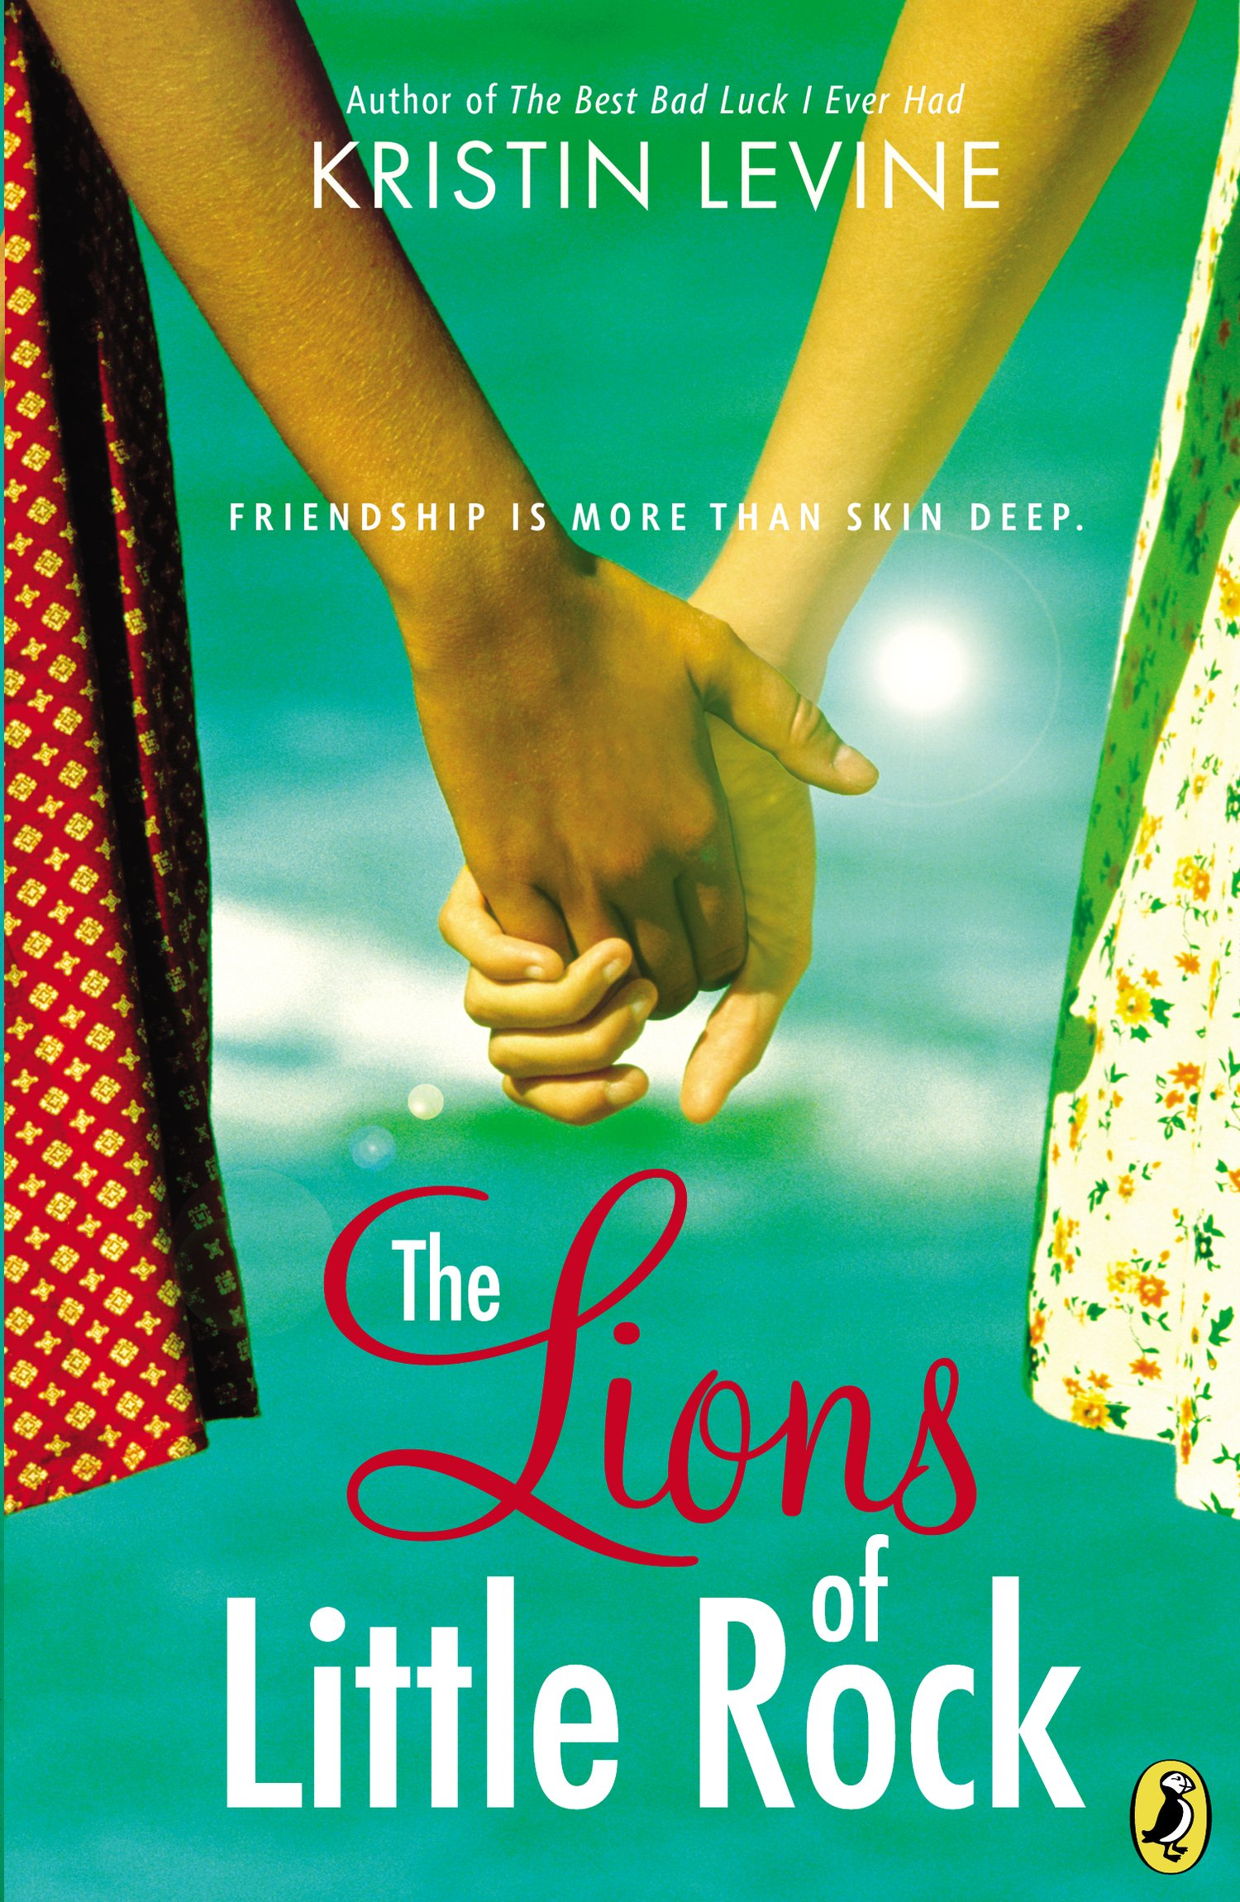
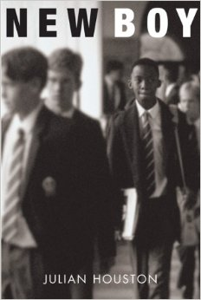
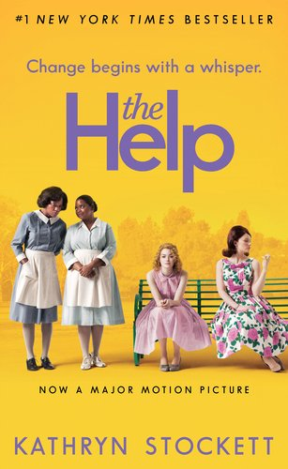
You will study the African-American experience through fiction and non-fictions books, articles, short stories, songs, films, and poetry. In literature circle groups, you will explore realistic and historical fiction texts. As a whole class, we will read the famous play, A Raisin in the Sun. You will take turns reading parts of the play and acting out scenes in class. You will have the chance to view parts of 2 different film versions to compare and contrast those to the play. This unit will include informational research and writing, poetry analysis, narrative writing, reading responses, presentations, and argumentative literary analysis.

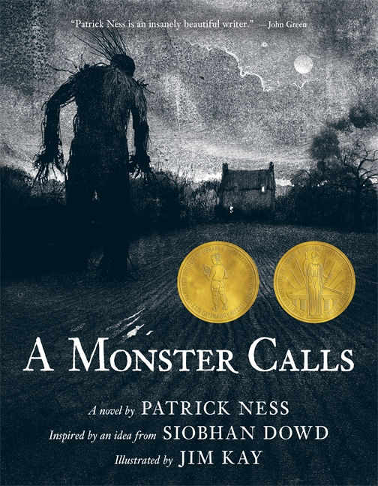
Family Influence: How does one’s family influence his/her actions, beliefs, & relationships?
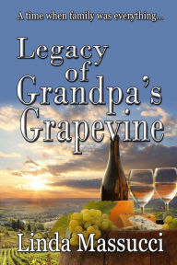
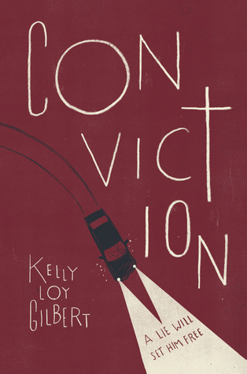
During this unit you will choose novels where the plot, conflict, and theme are strongly tied to the family relationships in the text. You will consider your own family and the role family plays in creating who we are as individuals. You will work with modified literature circle groups to read a text and develop a creative way to share your understandings about the book and the broader topic.

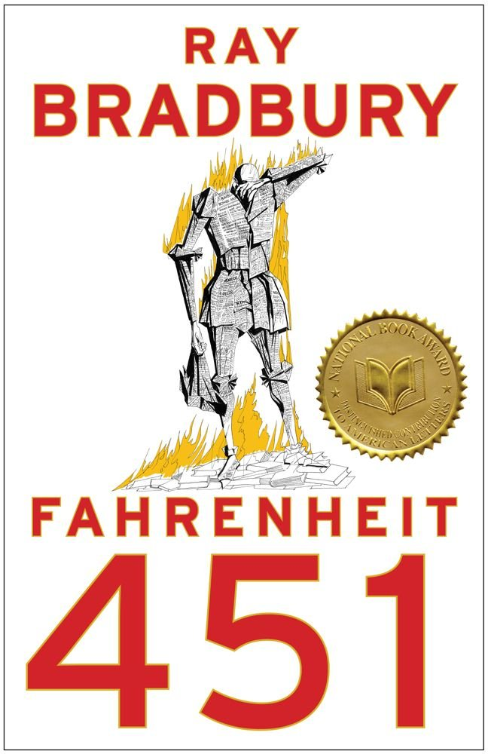
Human Nature: What makes us human? When do our “true colors” come out? How do we respond to adversity?
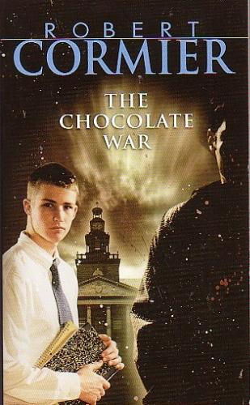
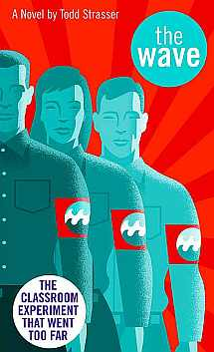
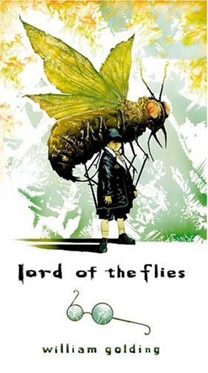
There are many famous novels which are meant to make a statement about the way humans can act when faced with adversity, corruption, control, and so on. These books force us to examine our own values and perceptions of the world around us. You will work in literature circles to explore some of these classic pieces. Some possible titles are: Lord of the Flies, The Wave, The Chocolate War, Fahrenheit 451, Animal Farm, and more.

*The units are subject to change. This is just a sample of what may be covered.

What should I know about GRADING?

- Homework: Homework helps you build responsibility, self-discipline, and lifelong learning habits. It is my intention to assign meaningful assignments that will help reinforce daily objectives and skills. Homework assignments may include completing work from the day’s lesson, preview or initiating activities for the next day, extension activities, reading assignments, written responses, or creative activities. Homework that isn’t done or isn’t fully complete will be recorded as part of your “Work Habits” grade. If are spending an inordinate amount of time completing Reading homework, please contact me to discuss this.
- Quizzes- 30%: This year you will continue to have quizzes on various concepts, vocabulary, and reading comprehension. You will always know when a quiz is coming.
- Formative Assessments- 20%: Formative assessments are often smaller assignments done both in class and at home that serve as a practice and a way to check for understanding throughout a unit. These assignments give me a chance to give you feedback on your progress and help us both to know what types of adjustments need to be made before we reach a summative assessment.
- Summative Assessments -50%: Summative Assessments include tests, projects, reports, essays, IRLs, technology projects, and more. These assessments are designed to see what you have learned during a unit. These may be completed in class and/or at home over an extended period of time. Most assessments will have a rubric to explain how you will be graded.

LATE work policy: You are expected to turn in all assignments and assessments on time. Work and reading completed at home are ESSENTIAL for class discussions, activities, group work, and participation. Late assignments of any kind will impact your “Work Habits” grade. Parents will also be notified of late or missing assignments via email in the form of a CCS Work Reminder. While late work will be accepted close to the due date, there will come a time when incomplete assignments will earn a zero.

What do I do if I am absent? If you are absent, please make every effort to get the work so you are prepared when you return to class. To find the assignments you should:
- Check the Middle School Homework page online(see link on school website) and/or Google Classroom to see what was assigned.
- Call, text, or email a classmate for more information.
Email me to ask questions or get clarification on what to do.
EMAIL: smagyar@cornwallschool.org PHONE: 860-672-6617 Ex: 100
- See me before or after class to discuss what you missed and what you need to make-up. Check the board or ask for handouts/assignments that were given while you were out.

Mrs. Magyar’s Classroom Guidelines:
- Be seated and ready to work when class begins.
- Follow directions.
3. Raise your hand for permission to speak or share. Save off-topic questions/comments for after class.
4. Ask permission to leave the room (Classroom Sign Language).
5. Wait to pack up until you have been dismissed.
6. Be careful with classroom books, supplies, and furniture.
7. Make good use of class time.
8. Always treat others with kindness and respect.

