**CCS Reading: GRADE 5/6**

Mrs. Magyar & Mrs. Collins



**What will I be doing in 5/6th Grade Reading?**

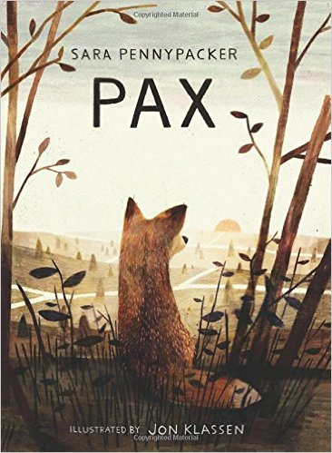You will focus on improving your reading skills through various activities that align with the CT Common Core standards. A variety of genres will be covered throughout the year. There are times when novels will be assigned and times when you will choose your own independent reading (IR) novels. You will also read short stories, non-fiction articles, and poetry. You will utilize your writing, and speaking/listening skills to respond to and share about what you read. You may also watch films or video clips and listen to music related to the units we are studying. New vocabulary words will come from each unit as well. This year you will work independently, in pairs, in small groups, and as a whole class. You will be asked to utilize your Chromebooks and Google accounts frequently. You will also incorporate other technologies whenever possible.

Here is a preview of topics you may see this year:

**Story elements & figurative language**

**The Global Read Aloud -*Pax*** by Sara Pennypacker

**Short stories and introduction/review of literature circles**

**Literature circle units: Genre study, Greek mythology,**

**Social issues & adversity**

**Independent reading & goal setting, IRLs, related technology projects**



**What do I need to have for Reading class?**

Please be sure to have the following items every day. Preparation is part of your “Work Habits” grade.

1. CCS planner & Homework folder
2. Binder with dividers & lined paper (this should be stored in the room)
3. Current class book & Independent reading (IR) book
4. Several pens or sharpened pencils
5. A positive attitude ☺

*\*You will be told when you need to bring your Chromebook. Check the board every day for details.*



**How do I need to act in class?**

As CCS continues the implementation of PBIS, it is expected that you will demonstrate ***safety, respect****, and* ***responsibility*** for yourself, your classmates, adults, and property in the classroom.  You are expected to follow the Coyotes’ Code.   If you do, you will be recognized for your efforts. There will be consequences if you act inappropriately or cause disruptions to the learning. A *CCS Behavior Report* will notify parents of reoccurring or significant behavior issues in/out of the classroom

**Mrs. Magyar’s Classroom Guidelines:**

1. *Be seated and ready to work when class begins.*
2. *Follow directions.*

*3. Raise your hand for permission to speak or share. Save off-topic questions/comments for after class.*

*4. Ask permission to leave the room (Classroom Sign Language).*

*5. Wait to pack up until you have been dismissed.*

*6. Be careful with classroom books, supplies, and furniture.*

*7. Make good use of class time.*

*8. Always treat others with kindness and respect.*



What should I know about grading?

Homework: Homework helps you build responsibility, self-discipline, and lifelong learning habits. It is my intention to assign meaningful assignments that will help reinforce daily objectives and skills. Homework assignments may include completing work from the day’s lesson, preview or initiating activities for the next day, extension activities, reading assignments, written responses, or creative activities. Homework that isn’t done or isn’t fully complete will be recorded as part of your “Work Habits” grade. If are spending an inordinate amount of time completing Reading homework, please contact me to discuss this.

Quizzes- 30%: This year you will have quizzes on various concepts, vocabulary, and reading comprehension. You will always know that a quiz is coming. Some tools will be provided (such as Quizlit for vocabulary or stickies for reading notes) but you are always encouraged to use the system that works best for you.

Formative Assessments- 20%: Formative assessments are often smaller assignments done both in class and at home that serve as a practice and a way to check for understanding throughout a unit. These assignments give me a chance to give you feedback on your progress and help us both to know what types of adjustments need to be made before we reach a summative assessment.

Summative Assessments -50%: Summative Assessments include tests, projects, reports, essays, independent reading logs (IRLs), technology projects, and more. These assessments are designed to see what you have learned during a unit. These may be completed in class and/or at home over an extended period of time. Most assessments will have a rubric to explain how you will be graded.

LATE work policy: You are expected to turn in all assignments and assessments on time. Work and reading completed at home are ESSENTIAL for class discussions, activities, group work, and participation. Late assignments of any kind will impact your “Work Habits” grade. Parents will also be notified of late or missing assignments via email in the form of a *CCS Work Reminder*. While late work will be accepted close to the due date, there will come a time when incomplete assignments will earn a zero.

Tips for success:

* Write down ALL assignments in your CCS Planner.
* Be sure you are clear about all assignments. Ask questions if you are unsure.
* Access the Middle School Homework Page online for assignments from home if needed.
* Set aside a regular time and location for homework and studying.
* Make good use of FLEX and class time given to complete assignments.
* Make sure you hand in only your own work (see the *Academic Honesty* *Policy)*.
* Bring ALL assignments to class ON TIME!
* Monitor your own progress by checking Powerschool (codes will be coming).

How parents & guardians can help:

* Check student’s planner or the online homework page to see what has been assigned.
* Access the parent portal on Powerschool to check student progress.
* Set regular, uninterrupted homework time every day.
* Monitor student’s organization and study habits.
* Email or call with questions or concerns.

EMAIL: [smagyar@cornwallschool.org](mailto:smagyar@cornwallschool.org) PHONE: 860-672-6617 Ex: 100

**What do I do if I am absent?** If you are absent, please make every effort to get the work so you are prepared when you return to class. To find the assignments you should:

* Check the Middle School Homework page online(see link on school website).l
* Call, text, or email a classmatefor more information.
* Email me to ask questions or get clarification on what to do.
* See me before or after class to discuss what you missed and what you need to make-up. Check the board or ask for handouts/assignments that were given while you were out.