**CCS English: GRADE 7**



**Grade 7 Titles/Topics*:**

The Holocaust:

Grade 7 will start with an in-depth study of the Holocaust through non-fiction and fiction texts, videos, articles and poetry. You will have a chance to research and read about the rise of Nazi Germany and the role that racism and anti-Semitism played in German society at that time. This material will be the basis for your 1st informative essay. During this unit, you will read stories of both hope and despair. The purpose of analyzing such dark moments in our history is not only to honor those who lost their lives, but to challenge us to define our own beliefs about justice, compassion, and human responsibility.

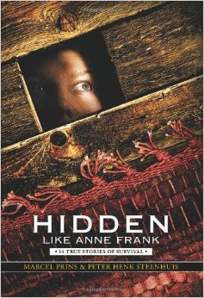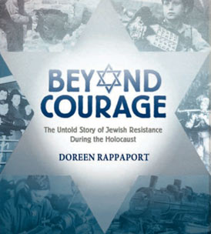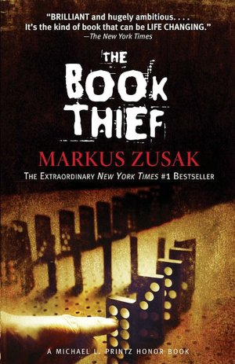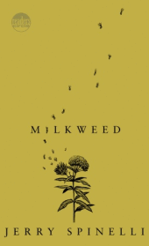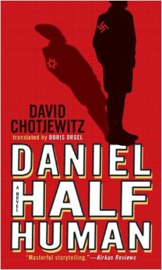

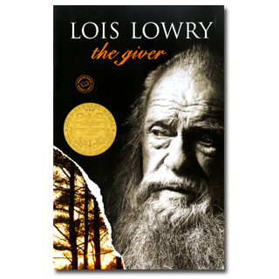Utopia/Dystopia:

Is there such thing as a perfect world? This year you will consider what you think makes a “perfect society” and the challenges that may go along with this goal. You will be introduced to real and fictional utopias in history and literature. We will read The Giver, a famous dystopian novel by the award winning author, Lois Lowry. Our experience with dystopian literature will provide a perfect springboard for argumentative writing individually and in small groups.

Science Fiction:

Science Fiction is a wide and popular genre filled with books based on the science and technology of the future world. You will work in literature circles to explore some great science fiction novels including: *The House of the Scorpion, Unwind, Dr. Franklin’s Island, Things Not Seen, Human 4, Life as We Knew It, Z for Zachariah,* *Uglies*, and more. Your small groups will allow you to work on vocabulary development, reading comprehension skills and speaking and listening standards. You will also work on collaborative

science fiction narrative stories.

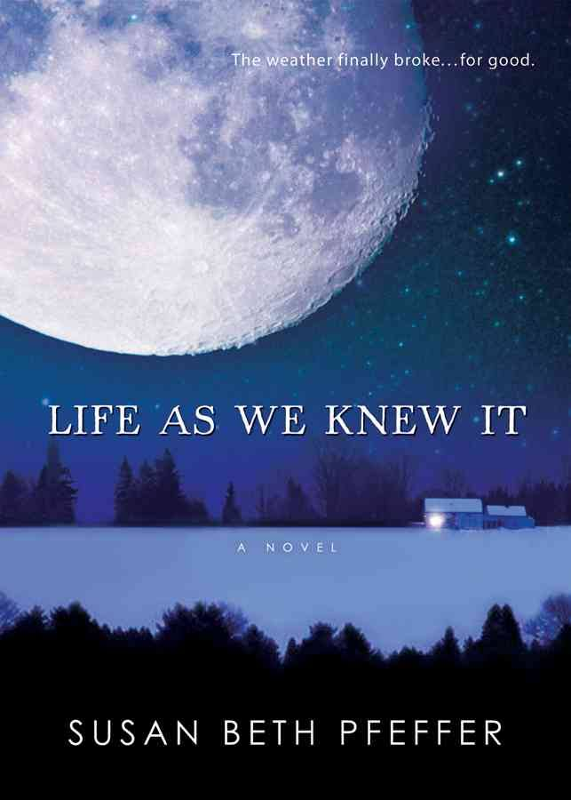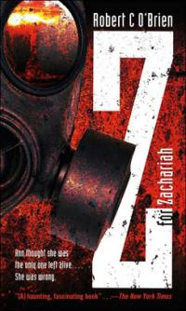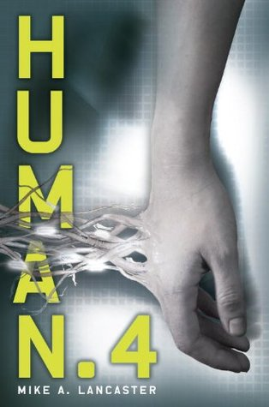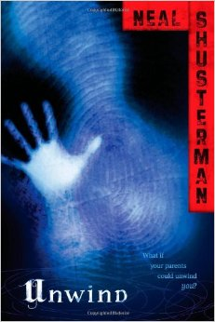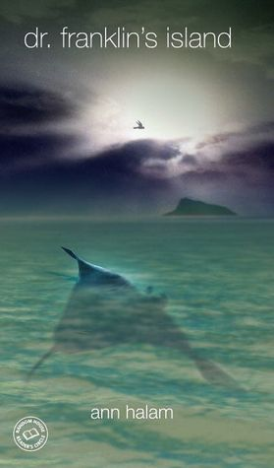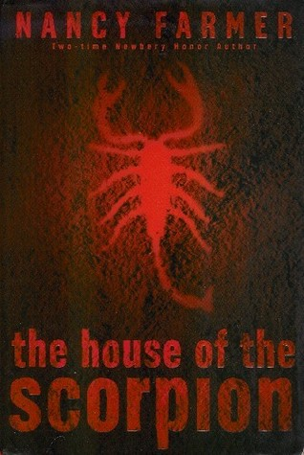

Identity of the Adolescent:

How do individuals define themselves? What causes people to change or grow? What does it feel like to be “in the middle”? These are all questions you will consider in this unit on adolescent identity. In literature circle groups, you will read stories of teenagers, much like yourself, who are trying to figure out “who they are” and what they stand for. This will be another great place to incorporate personal narrative and poetry writing.

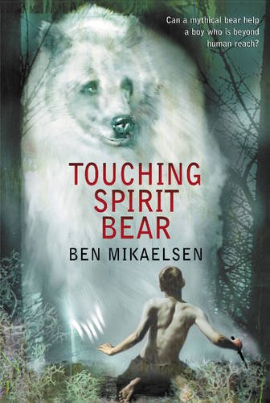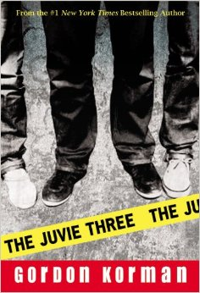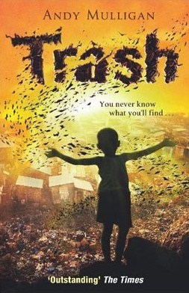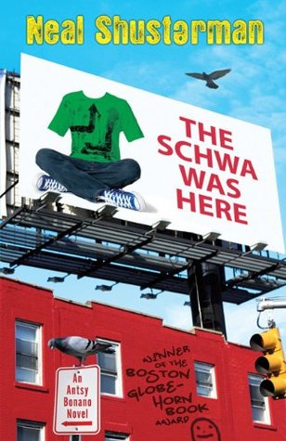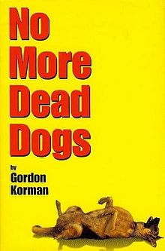

*\*The topics/titles above are subject to change. This is just a sample of what will be covered.*

**Overview:**

This year you will continue to practice reading, writing, speaking and listening skills through various activities that align with the CT Common Core Standards for grade 7. There will still be whole class novels, literature circles, and independent reading (IR) books. You will also read short stories, non-fiction articles, and poetry. You will write about what you read in many different ways, including the 3 main types of writing outlined in the CT Common Core: Argumentative, Narrative, and Informative. You will continue to work on story elements, figurative language, vocabulary development, collaboration, and presentation skills. You will work independently, in pairs, in small groups, and as a whole class. You will be asked to utilize the chrome books and your Google accounts regularly. You will be asked to incorporate other technologies whenever possible.



**What do I need to have for English class?**

Please be sure to have the following items every day. Remember, the prep chart is marked if you are unprepared.

1. CCS planner
2. Homework folder
3. Binder with dividers & lined paper (this should be stored in the room)
4. Writer’s Notebook (this may also be stored in room)
5. Current class book
6. Independent reading (IR) book
7. Your Chromebook (charged or with charger)
8. Several pens or sharpened pencils
9. A positive attitude ☺



**How do I need to act in class?**

As all of CCS continues the implementation of PBIS, it is expected that you will demonstrate ***safety, respect****, and* ***responsibility*** for yourself, your classmates, adults, and property in the classroom.  You are expected to follow the Coyotes’ Code.   If you do, you will be recognized for your efforts. There will be consequences if you act inappropriately or cause disruptions to the learning. A *CCS Behavior Report* will notify parents of reoccurring or significant behavior issues in/out of the classroom.

**Mrs. Magyar’s Classroom Guidelines:**

*1. Treat others with kindness and respect.*

*2. Follow directions.*

*3. Be seated and ready to work when class begins.*

*4. Raise your hand for permission to speak or share.*

*5. Save off-topic questions/comments for after class.*

*6. Ask permission to leave your seat (Classroom Sign Language).*

*7. Wait to pack up until you have been dismissed.*

*8. Be careful with classroom books, supplies, and furniture.*

*9. Make good use of class time.*



**How will I be graded?**

ASSESSMENTS (Tests, Projects, Essays, IRLs) ……………………………………………………50%

QUIZZES………………………………………………………………….30%

HOMEWORK/CLASSWORK/PREPARATION……………………………………….….20%



What should I know about homework & assignments?

Purpose of Homework:

Homework helps you build responsibility, self-discipline, and lifelong learning habits. It is my intention to assign meaningful assignments that will help reinforce daily objectives and skills. Homework assignments may include completing work from the day’s lesson, preview or initiating activities for the next day, extension activities, reading assignments, written responses, or creative activities. If are spending an inordinate amount of time completing English homework, please contact me to discuss this.

LATE work policy:

You are expected to turn assignments in on time. Work and reading completed at home is ESSENTIAL for class discussions and activities, group work, and participation. Any completed assignment turned in late will earn a 50%. Parents will also be notified of missed assignments via email in the form of a *CCS Work Reminder*.

Long-term Assignments:

Long-term assignments include projects, reports, essays, independent reading logs and assessments, technology projects and more. They are completed in class and/or at home over an extended period of time. Most long-term assignments will have a rubric to explain how they will be graded. Completed assignments must be turned on the due date. Any completed long term assignment turned in after the due date will receive a penalty of 10% off per school day (electronic submissions include weekends). Any completed long-term project turned in after 5 days will earn a 50%.

Tips for success:

* Write down ALL assignments in your CCS Planner
* Access the Middle School Homework Page for assignments from home if needed
* Be sure you are clear about all assignments. Ask questions if you are unsure.
* Set aside a regular time and location for homework and studying.
* Make good use of FLEX and class time given to complete assignments.
* Keep assignments organized.
* Make sure you hand in only your own work (see the middle school policy on *Academic Honesty* for more information).
* Bring ALL assignments to class ON TIME!

How parents & guardians can help:

* Check student’s planner or the homework page to see what has been assigned.
* Set regular, uninterrupted homework time every day.
* Monitor student’s organization and study habits.
* Email or call me with questions or concerns.

**EMAIL:** [**smagyar@cornwallschool.org**](mailto:smagyar@cornwallschool.org)

**PHONE: 860-672-6617 Ex: 100**

**What to do if you are absent:**

If you are absent, please make every effort to get the work so you are prepared when you return to class. To find the assignments you should:

1. Check the CCS Middle School Homework page for the weekly assignments. This link is found on the school website.
2. Call, text, or email a classmatefor more information.
3. Email me to ask questions or get clarification on what to do.
4. See me before or after class to discuss what you missed and what you need to make-up. Check the board or ask for handouts/assignments that were given while you were out.

*REMEMBER: It is your responsibility to get and make up all missed work!*